22BCE5252

ANIRUDH SRIDHAR

OOPS ASSIGNMENT-4

1)

Code:

#include <stdio.h>

int main() {

int n;

printf("Hello world! Enter limit:");

scanf("%d", &n);

int x[n];

int \*p = &x;

for (int i=0; i<n; i++) {

int a;

printf("\nEnter element: ");

scanf("%d", &a);

\*(p+i)=a;

}

int y;

printf("\nEnter difference to search for: ");

scanf("%d", &y);

int k=0;

for (int i=0; i<n; i++) {

for (int j=0; j<n; j++) {

if ((\*(p+i)-\*(p+j)) == y) {

k=1;

printf("\n%d %d\n\n", \*(p+i), \*(p+j));

}

}

}

if (k==0) {

printf("\n no pair exists");

}

return 0;

}

Output:

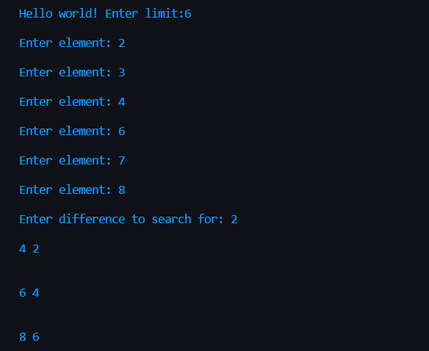

2)

Code:

#include <stdio.h>

#include <stdlib.h>

#define swap(a, b) a^=b; b^=a; a^=b

void merge(int \*a1, int \*a2, int s1, int s2) {

int \*res;

res= (int\*)malloc((s1+s2)\*sizeof(int));

int \*ptr1 = &a1[0];

int \*ptr2 = &a2[0];

int \*ptr3 = &res[0];

for (int i= 0; i < s1; i++) {

\*(ptr3+i) = \*(ptr1+i);

}

for (int i= 0; i < s2; i++) {

\*(ptr3+s1+i) = \*(ptr2+i);

}

for (int i= 0; i < (s1+ s2); i++) {

for (int j= i+1; j < (s1+s2); j++) {

if (\*(ptr3+i) > \*(ptr3+j)) {

swap(\*(ptr3+i), \*(ptr3+j));

}

}

}

printf("The merged array is: \n");

for (int i= 0; i< (s1+s2); i++) {

printf("%d ", \*(ptr3 + i));

}

printf("\n");

}

int main() {

int n1, n2;

printf("Enter size of array 1: \n");

scanf("%d", &n1);

int \*a1 = (int\*)malloc((n1)\*sizeof(int));

printf("Enter elements of array 1: \n");

for (int i= 0; i < n1; i++) {

scanf("%d", &a1[i]);

}

printf("\n");

printf("Enter size of array 2: \n");

scanf("%d", &n2);

int \*a2 = (int\*)malloc((n2)\*sizeof(int));

printf("Enter elements of array 2: \n");

for (int i= 0; i < n2; i++) {

scanf("%d", &a2[i]);

}

merge(a1, a2, n1, n2);

}

Output:

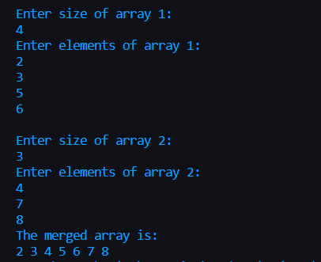

3)

Code:

#include <stdio.h>

#include <string.h>

#include <stdlib.h>

#define max 1000

int equilibrium(int n, int \*arr) {

//if n is even, n = n/2

//if n is odd, n = (n\*3) + 1

int k= 0;

int\* ptr= &arr[0];

while (n != 1) {

if (n % 2 == 0) {

n/=2;

\*(ptr+k) = n;

}

else {

n = (n\*3)+1;

\*(ptr+k) = n;

}

k++;

}

\*(ptr+k) = 1;

return k;

}

int main() {

int n;

printf("Enter number: \n");

scanf("%d", &n);

int\* arr= (int\*)calloc(max, sizeof(int));

int k= equilibrium(n, arr);

printf("The pathway generated is: \n");

printf("%d --> ", n);

for (int i= 0; i < k; i++) {

if (arr[i] == 1) {

printf("%d \n", arr[i]);

}

else {

printf("%d --> ", arr[i]);

}

}

return 0;

}

Output:

4)

Code:

#include <stdio.h>

int month [ 12 ] = { 31 , 28 , 31 , 30 , 31 , 30 , 31 , 31 , 30 , 31 , 30 , 31 } ;

char mn[][20] = {"January", "February", "March", "April", "May", "June", "July", "August", "September", "October",

"November", "December"};

int \*mp = &month;

int main() {

int d,m,y,s=0;

printf("Please enter your day, month and year as dd mm yyyy ");

scanf("%d %d %d", &d, &m, &y);

if ((y % 400 == 0 ) || ((y % 4 == 0) && (y%100!=0)))

month [ 1 ] = 29 ;

for (int i = 0 ; i < m-1 ;i++) {

s = s + \*(mp+i) ;

s = s + (d+y+(y/4)-2) ;

s = s%7;

}

switch (s) {

case 0:

printf("Sunday, %s %d.\n", mn[m-1],y);

break;

case 1:

printf("Monday, %s %d.\n", mn[m-1],y);

break;

case 2:

printf("Tuesday, %s %d.\n", mn[m],y);

break;

case 3:

printf("Wednesday, %s %d.\n", mn[m],y);

break;

case 4:

printf("Thursday, %s %d.\n", mn[m],y);

break;

case 5:

printf("Friday, %s %d.\n", mn[m],y);

break;

case 6:

printf("Saturday, %s %d.\n", mn[m],y);

break;

default:

printf("\nError: Invalid data input\n");

break;

}

}

Output:

